Building evidence on impact from gender action in coffee
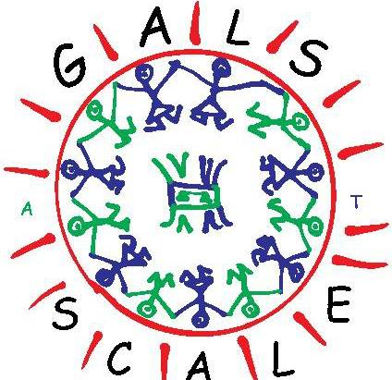
By Catherine van der Wees
Amsterdam, September 2016
What is the evidence? Providing evidence that gender programmes have an impact is a frequently asked question. As gender is becoming an important theme in coffee and other global value chains, stakeholders are looking for approaches and methodologies that work. In this article I will provide the evidence available so far of the Gender Action Learning Systems (GALS) approach that was implemented by Bukonzo Joint Cooperative Union, which has been implementing GALS for 10 years now and since 2013 with Ecom Agro-industrial Corporation and Hivos in Tanzania, Kenya and since April 2016 in Indonesia. All Hivos programmes together using this approach are called Gender Action Learning for Sustainability at Scale.
- The problem
In coffee production in Uganda, Tanzania, Kenya, Indonesia and elsewhere, women perform a lot of the work, however, most of them do not own the land, receive very little training, and have little or no say over the income from coffee, especially if they are married. Because of this, there is little incentive for women to improve coffee, and they rather concentrate on products over which they have more control. As a consequence, coffee production stagnates and coffee programmes aimed at increasing coffee production or improving quality do not yield good results.
It does not have to be that way, it is possible to increase productivity and improve quality of coffee, and at the same time reduce gender inequalities. Below I describe the implementation of gender action programmes in Uganda, Tanzania, Kenya and Indonesia.
Below are two infograms showing the transformation from “an old men’s hobby”, as it was once called by a youth, towards a profitable coffee farming family business.
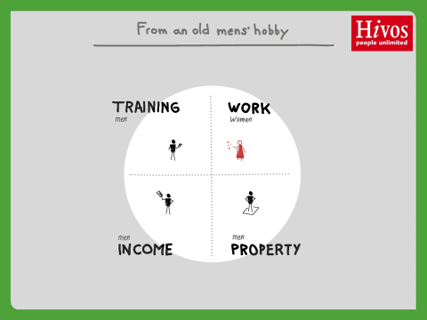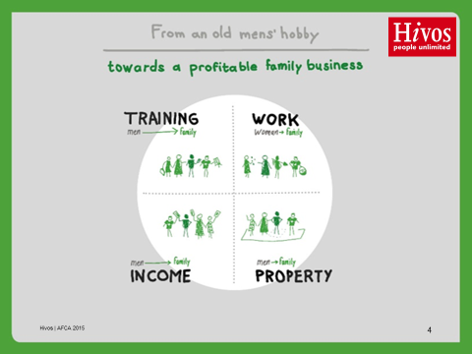

- Implementation
Bukonzo Joint Cooperative Union in Uganda
Bukonzo Joint Cooperative Union (BJCU) is a successful member-managed cooperative union, with a well-established savings and credit programme, and profitable coffee marketing, located in the remote mountain villages around Kyarumba in Western Uganda. Bukonzo Joint Cooperative Union started in 1999 with 98% women who were from 11 Savings and Credit self-help groups each group were between 15 to 30 members. Todate, BJCU has over 5000 members, of which 85 % are women, and 55 % majority women on the elected board.
Bukonzo Joint was one of the original organisations using Participatory Action Learning System since 2003 for its planning and member training. In 2007 it started using Gender Action Learning Systems (GALS).
Use of GALS methodology has been a key factor in enabling Bukonzo Joint members to efficiently implement other trainings like Good Agricultural Practices, and increasing quality and quantity coffee to become the successful coffee cooperative it is today. In 2015 it won the SCAA Sustainability Award for gender mainstreaming in the coffee sector.

Coffee Partnership for Tanzania
Ecom Ago-Industrial Corporation Ltd. and Hivos, starting working together in Kenya in 2007, setting up Sustainable Management Services, a subsidiary of ECOM, focusing on working and trading with farmers. When the Coffee Partnership for Tanzania (CPT) was developed, Tutunze Kahawa LTd. (TKL) and Coffee Management Services (CMS), asked Hivos to collaborate in this, and develop, among other things, a gender component. When the programme was approved, the additional Hivos components were co-funded by the Netherlands Government. The gender component consisted of a number of components, spread over two years, using the Gender Action Learning Systems’ (GALS) approach. It started with an one week training of 20 farmers, (9 female and 11 male) in Same, Kilimanjaro Region, Northern Tanzania. This was followed by community workshops in the villages where the farmers came from.
In the first training farmers learnt how to develop individual visions, plan how to achieve their vision with SMART milestones, analyse opportunities and constraints, commit to actions and trach their progress over time. They get insight whether their own situation is balanced in terms of labour, assets, decision making and expenditure behavior and determine what they want to change, and track these changes over time. They scale up the methodology through their own social networks.
In June and July 2014, this was followed by similar training in Illela and Ngima, two villages in Mbeya Region, Southern Tanzania. In Ngima, the CMS GALS process started with a 5-day catalyst workshop, facilitated by Linda Mayoux and 2 champions from Bukonzo Joint (Asasio Balitebya and Doviko Walina). The catalyst workshop trained 25 champions – 13 male & 12 female (15 staff and 10 farmers). As part of the Catalyst workshop there was a half day community workshop in Ngima. The community workshop was organized by the champions who brought a further 12 women and 21 men and introduced how to develop an individual vision and vision plan. A follow up was made in July 2014.
In February 2014 a workshop on “Gender Strategies in Coffee in East Africa” was held in Same. The overall objective of the workshop was to share vision, strategies and experiences for promoting gender justice between different approaches and partners working in coffee in East Africa and come to an aligned approach, strategy and concrete action for CPT and 4S@scale and possibly other programmes. In total 35 people participated, among which 16 farmers, 14 from Same, and 2 from the South of Tanzania.
In November 2014, another meeting was held in Same with the aim to do a leadership training, have a meeting with village and sub-village participants, monitor and profile the champions, and have a meeting with Same District Commissioner and District Executive Director.
In February 2015, 2 female and 2 male farmers from the three locations in Tanzania as well as 4 female and 4 male farmers from 4S@scale in Kenya came to Bukonzo Joint Cooperative Union in Western Uganda to learn from each other.
A last training was conducted in November 2015 in Illela and Ngima to develop a GALS/Good Agricultural Practices curriculum and training manual with ECOM and Hivos staff.
At the Cooperative Union level the five primary societies and the union were assisted to develop a gender balanced vision, and identify characteristics of good membership and leadership and a vision journey plan that they are in the process of implementing for increasing women’s membership and board members. At least three of the original champions have been elected to leadership positions.
Sustainable and Secure Smallholder Systems at Scale in Kenya
The first workshops started out well in July 2014 with 40 champions (20 women and 20 men) trained in West Kenya. Shortly after, another 40 champions (20 women and 20 men) were trained in Eastern Kenya. Although many new champions were trained both by the original champions, as well as SMS staff since then, there is no record of total champions trained, nor what the impact has been on productivity and quality of coffee or on gender relations. It is planned to do this later in 2016.
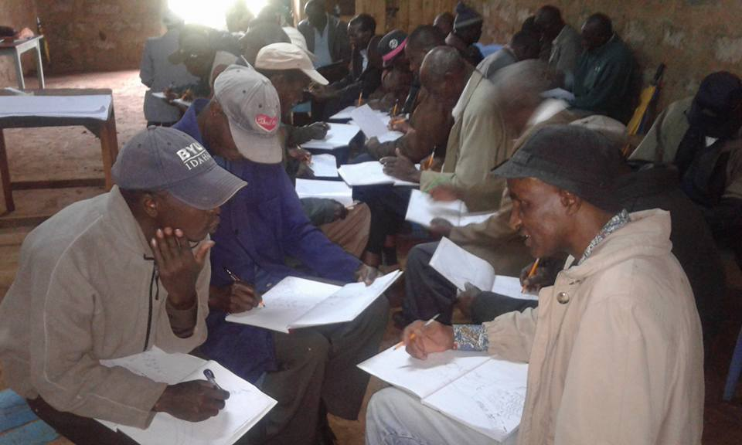
Foto: Peter Ndambiri
Semendo Programme in Indonesia
Ecom (indoCafCo or ICC) and Hivos started another process in Semendo, Southern Sumatra, Indonesia in April 2016. 10 couples were trained in an one week catalyst workshop.
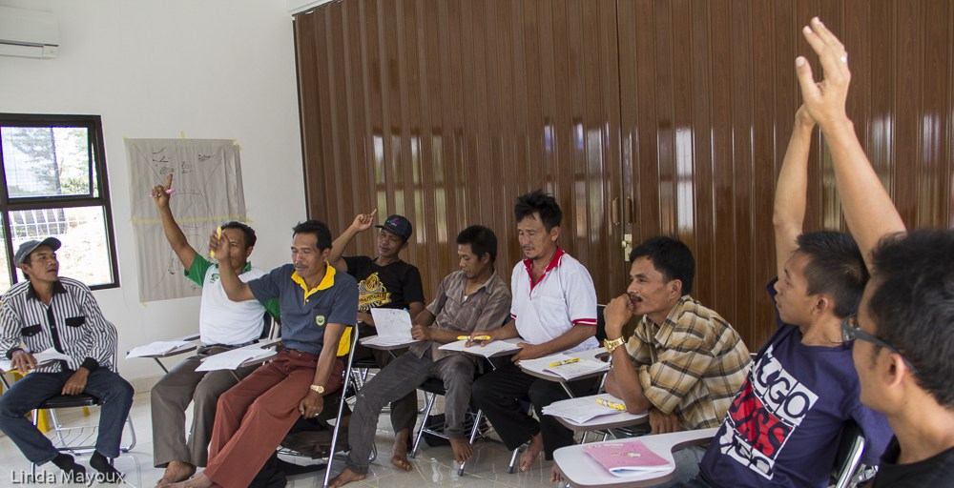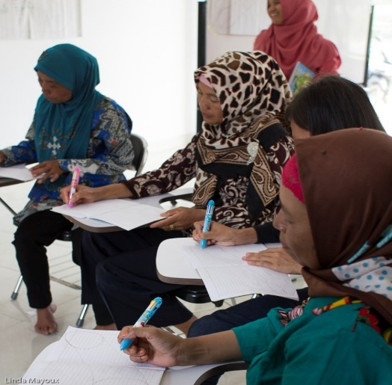

- Evidence
We will look at three different aspects of evidence: productivity and quality of coffee; gender aspects and lastly, outreach by the farmers.
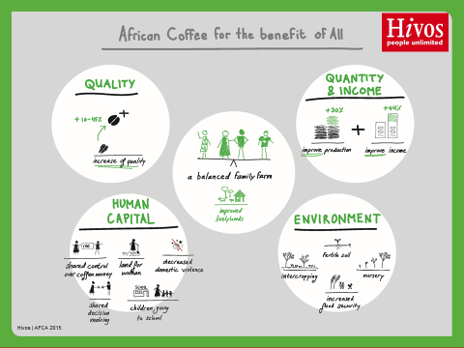

Productivity and quality of coffee
Uganda
BJCU increased its quality from 77 in 2011 to 85.74 in 2014, which is continuing to date. The coffee is organic and fair trade certified.

Quantity increased substantially as well. In 2011, BJCU exported 57600 kg of coffee, in 2012 this has increased to 75.600 kg, in 2013 178.020 and in 2014 161,460kg.
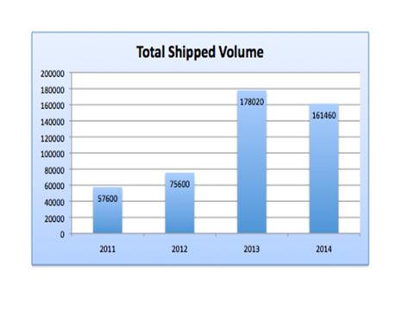
Source: Bukonzo Joint Cooperative Union, June 2016
Sales by farmers to BJCU increased from an initial USD 11,911 in 2005 to USD 244,240 in 2008 after the GALS training in 2007, and continued to improve to USD 469,178 in 2013. BJCU receives loans from Rabobank Foundation to buy coffee from farmers.

Linda Mayoux reports in a study in 2011:
“The actions that women and men had planned and that finally helped them to increase the quality of the coffee they sell, include:
- Men stopped ‘taking’ the coffee (that women had worked for) and selling to traders around bars without consulting the woman. They started joint planning and can count on benefits from coffee sales that are proportionate to their labour input, which motivated both women and men to increase the quality.
- Urging the police to act against thieves has led to the punishment of some thieves that used to steal their coffee drying outside the house.
- Farmers have reduced manual hulling with sticks and increased mechanised hulling (712 farmers), which improved the quality. They have also practiced more cleanliness during drying.
- Harvesting of green/unripe coffee for emergency sales has decreased, which improved the coffee.
- Households have increased their other income generating activities and are able to save more money. They are less vulnerable to harassment from middle buyers to sell coffee.
- 385 farmers are now drinking the coffee by themselves, which was not done before the project. They now see it more as a consumption product rather than a commodity, are therefore more conscious of the quality.

Description | Result Sept 2010 | Result March 2011
Number of trained households that has been able to improve coffee quality, and share the benefits equally and proportionate to labour contributions | 394 | 1267
Number of trained households that started improved quality practices, but still have challenges with storage, drying materials, and partly still selling to middle-buyers instead of the cooperative. | 415 | 637
Number of trained households that do not show any change and still sell part of their coffee to middle-buyers as they used to do. | 202 | 813
Number of households not yet trained | 1399 | 0
Total | 2717 | 2717

Tanzania
Many of the Tanzania champions either increased production, and/or increased the number of coffee trees. See the profile of Mr. Amani.
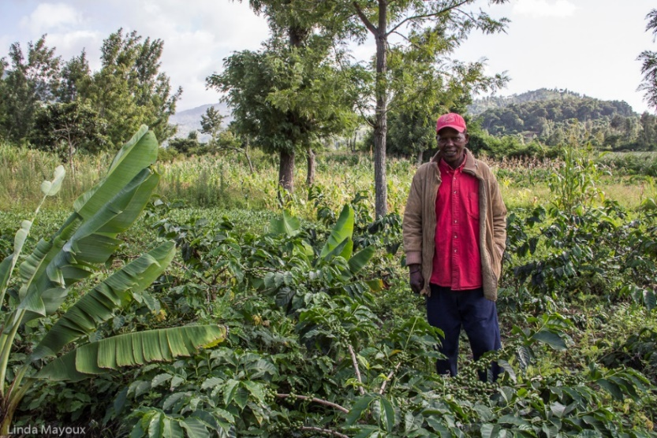

Mr Amani Mberuseru was one of the first GALS champions trained in October 2013. At that time he had a very serious drinking problem and was not looking after his farm.
In June 2014 he made a Vision Journey Plan for coffee, planning to increase increase production. This he achieved and has increased to 30 bags of coffee season 2014/2015, some of which he was taking to the Chome cooperative. He says he has the best coffee farm in Chome and all is because of planning through the vision journey.

Figures on productivity are available from Vuasu Cooperative Union, where the champions from Same came from. The most active champions came from Bwanbo, Gandu and Chome, which are also the primary cooperatives with an increase in production. Vuchama and Raa, where there are either very few champions or not active, did not increase their production. The five cooperatives involved increased coffee production by 9% and income by 12% in the 2013/4 coffee season. They currently account for 62% of the total coffee deliveries to the union.

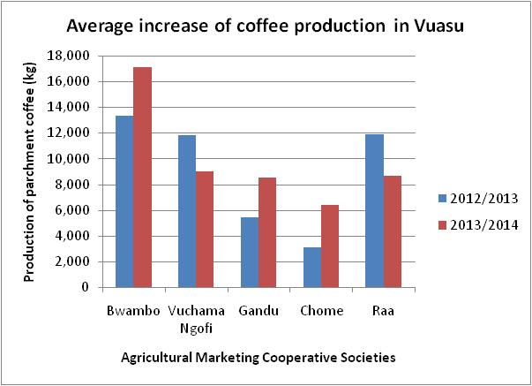Information: Vuasu Cooperative Union
As we have seen in the previous section, when GALS is used in combination with other support efforts, such as training in Good Agricultural Practices, finance and access to markets, the efficiency and effectivity increases substantially.
Indonesia
In 2012 ECOM implemented a gender programme (not GALS) in collaboration with IFC in Northern Sumatra, and reported on the results as follows:

As we can see from the above graph, productivity and income is highest when a support programme is implemented with a gender programme, higher than a support programme without gender component.
Gender
Uganda
Linda Mayoux conducted a study on BJCU in 2011, reporting quantitatively on gender changes:
Access and control over land
Between September 2010 and the last monitoring moment in March 2011 the progress on the inequalities in access and control over land changed as follows:
Description | Result Sept 2010 | Result March 2011
Number of trained households reporting that husband and wife legally changed the government land lease agreement to have a joint lease for  the husband and wife | 25 | 66
Number of trained households reporting that husband and wife negotiated with the family/in laws and signed an agreement with the local government  securing access and control over the land by the women in case their husband would die | 61 | 2068
Number of trained households with no change due to family and community challenges | 1005 | 583
Number of households not yet trained through peer learning, out of the 2717 planned in Bukonzo Joint Road Journey | 1399 | 0
Total | 2717 | 2717

TWIN, in a study on “Women, coffee and land” reports, that BJCU has promoted voluntary land agreements between husband and wife, which are now widespread. They use processes such as certification to formalise this joint land ownership within the producer organisation. More formal registration requires a lot of “incentives” for government officials, who also hold the cultural perception that land should be registered in the name of the men only, despite more equal legislation. (TWIN 2016:9)

Equal division of labour in coffee production and processing

The change regarding the unequal division of labour and benefits from the coffee value chain was equally monitored. In September 2010 around 34% of the households indicated that they are now sharing the work and benefits from coffee more equally, in 41% of the households the men started sharing the household chores with their wives, and in 25% of the households women reported that they are still doing practically all the work alone. There were also tangible results in terms of increased control of women over income. Six months after, March 2011, monitoring showed the following:
Description | Result Sept 2010 | Result March 2011
Number of trained households that are working together and started supporting each other with the work in the farm and in the house | 366 | 964
Number of trained households where men now participate in the chores in the house | 449 | 635
Number of trained women reporting that they are still doing the household work alone | 276 | 1118
Number of households not yet trained through peer learning out of the 2717 planned | 1399 | 0
Total | 2717 | 2717

This means that through the peer learning almost 60% of the households reported a positive change towards a more equal division of labour between women and men. 35% of the households report that women and men in the household share work both in the farm and in the house. In the six months before the last monitoring moment in March 2011 a significant number of households has been reached through peer training, which explains the increase in women reporting no change yet.
Apart from her study, there is very little quantified evidence on change in gender relations.
However, there is much qualitative evidence available. See the stories of the Tanzania champions on https://galsnetworkblog.net/

Tanzania
Kilimanjaro Region
In Kilimanjaro region, 200 of those taught were in the process of getting joint land agreements, adding names of women and children. More had made changes in decision making and division of labour. Very many had achieved visions on livelihoods. The training on livelihoods and leadership aroused a lot of enthusiasm. Follow up with Vuasu indicated that there had been sincere efforts to increase women’s membership of the Board.
But women were not very attracted to the role because they had too many other things to do and did not find enough incentives.
See below a story of one of the first champions, Dina, and her change process.
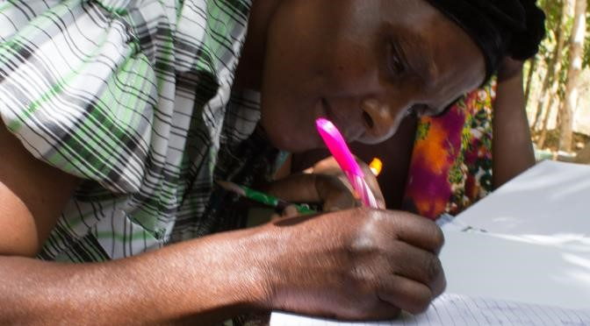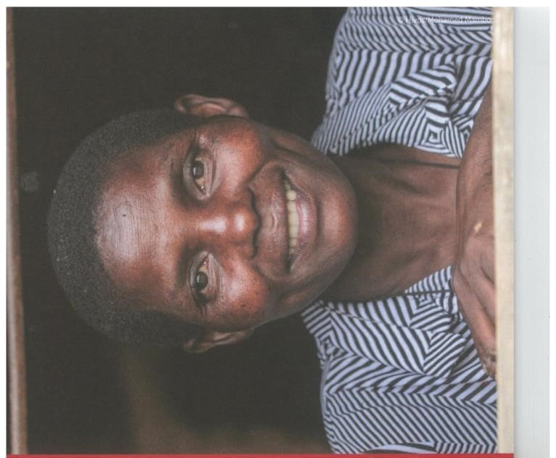
Dina’s story
Dina is a coffee farmer, who lives in Bwambo, a tiny mountain village in the Northwest of Tanzania, near Mount Kilimanjaro and the Kenyan border. Dina had a lot of challenges when her husband died, her brother-in-law tried to force her to marry him because he wanted to take her property. Her in-laws beat her several times, knocking out her front teeth, and threatened to kill her. Her children did not continue with school due to lack of school fees. Her sons went to find local jobs. Her daughters got married at a young age.
She went to court several times but the in-laws would bribe at the primary courts and win. Dina finally was helped by the government and local Vuasu cooperative staff and managed to she acquire her land. But she still had no money and was practically destitute. Looking back on that time, she says she was very depressed and with no hope for the future.
Dina says her situation has improved considerably after the Gender Action Leaning for Sustainability at Scale one week champions’ training in October 2013. She gained the confidence she needed to make decisions herself and developed a long term vision. She now has direction. She has renovated her house and has 20 chickens now. She got new teeth. She has been mentored by another champion Ann Eliuza Mweta, the only female Vuasu Cooperative Board member and helped through her savings group and church group. She was also nominated to become one of the new women Vuasu Board members who were being encouraged as a result of the new Vuasu Organisational Vision Plan. She has become a respected person in Bwambo, assisting her village with her knowledge about farming. Learning changed her life and now she is changing the lives of others. She has reason to smile again, not just because of her new teeth.

Mbeya Region
From a mid-term review, done by NORC University, of the CPT in April 2015, results from focused group discussions in Illela and Ngima villages, where the gender component was implemented, are as follows:
“The GALS training was only done in two villages (Ilela and Ngima), and was a major success in both places. In Ilela, as a result of the training, men started doing household chores, and women were involved in financial decision making. Respondents said that even strangers had told them that “their farms have really changed”: “men can go buy fish, which wasn’t possible before”; “drinking has reduced”; and “some of us even own cows now.” The training has had a spillover effect on families not even involved: “they see me as a man carrying firewood and this is so surprising, they wish to join and learn.” Women and men divide coffee-related tasks: women fetch water and kill flies, men spray chemicals and do pruning, and both men and women do weeding together. One farmer said: “The man was the final decision maker…after the training this has changed, and when we look at our farms, they’ve changed compared to others nearby.”
In Ngima, results were similarly encouraging. Farmers said that cooperation between men and women is now seen as very important, especially with decisions about money. “Before the training I had no plans, it was all spur of the moment, but now I sit down and come up with an itinerary of my activities,” reported one man; another said “before I was a drunkard, but now I’ve realized my mistake and brought my wife on board.” As in Ilela, men and women divide agricultural tasks: men carry equipment and women water, and both work together to create a plan for the upcoming season”.

Indonesia
In relation to gender aspects, there is gender inequality in almost all aspects: ownership, decision making, expenditures, productive and reproductive labour. Men do more productive labour, and are involved in a number of income generating activities, such as motorcycle taxi, daily wage labour in construction and agriculture, women also do daily wage labour in agriculture. However, women earn much less (Rp. 30,000) than men (Rp 50,000 / day), despite equal pay legislation. Both men and women are involved in coffee production, and postharvest activities, as well as in growing paddy. Women do much of the reproductive work. Mostly women and men discuss issues before the men takes the final decision. Women can take their own decisions in relation to paddy and their own business. As Semendo is a matrilineal society, first born daughters inherit both house and land from their parents, making the ownership of assets less unequal.
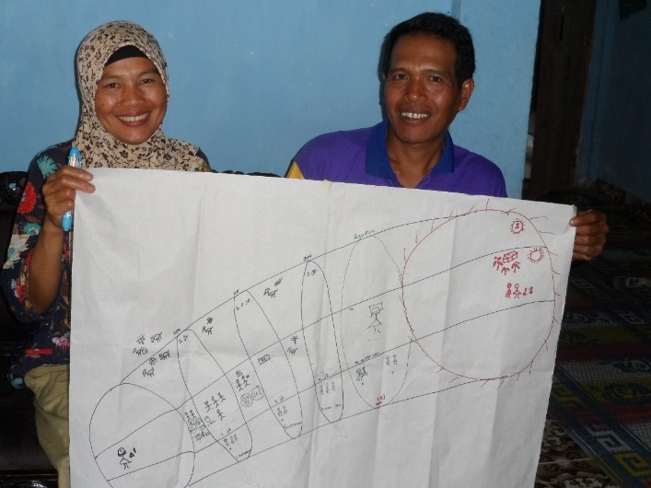
There are a lot of challenges in coffee, and most farmers feel their quantity and quality of coffee is not yet such that they can sell to ICC, they also see transporting the coffee to ICC as a constraint, and do not own bank accounts. They expect much for a cooperative society at village level. Here is much potential for ICC. The indebtedness of farmers to middlemen is widespread.
Through the training the champions became more aware of the gender issues, developed a vision as a couple and their first intended change focusses on reducing costs, and increasing income through an additional business for the wife, supported by the husband, thereby setting important first steps in the reduction of debt and dependence of the moneylender, in a gender sensitive way. Through monitoring of their coffee production and comparing with non-GALS champions the project will be able to monitor changes in this area as well.

Outreach
Tanzania
By February 2015 in Vuasu, 1531 people (806 men and 725 female) had been trained in GALS by the original 20 champions.
In Ngima, of the original 12 champions, 2 had moved out of the area. The 10 remaining champions had shared the GALS methodology with 471 other people. 40 people had started Upendo Savings and Credit Group. And a new group at the TAG church had also just formed.
By April 2015 the number of champions had grown from the original 20 in June 2014 to 106 (48 women) in Illela. New champions were not trained so well, and many of the old champions did not show so much commitment.

Interest by other stakeholders in Tanzania
In Kilimanjaro region there is strong interest from local government in rolling GALS out with local government extension workers. Strong interested in developing GALS processes and funding proposals by other local NGOs as well.

Indonesia
Through their social networks the 20 champions trained in Semendo, plan to upscale the methodology to another 241 persons.
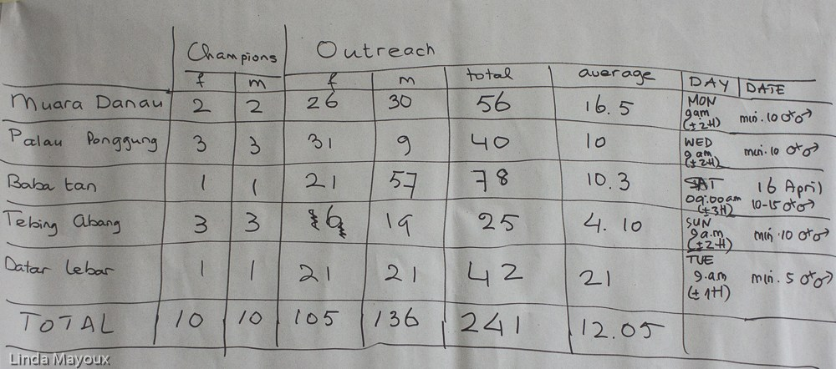
Foto’s: Linda Mayoux (above) and Catherine van der Wees (below)
In community workshops in 5 communities, another 88 farmers were trained by the original 10 couples in the vision and the beginning of the vision journey. All champions were followed up during the community days, and from their visions, gender analysis in the household, challenges in coffee production, and first results after the training, we derive at the following conclusions.

- Conclusions
Three GALS processes as started by Bukonzo Joint Cooperative Union in Uganda and later implemented in Tanzania, Kenya and recently in Indonesia by Ecom together with Hivos have met a lot of enthusiasm by the farmers, resulted in improved quality and quantity of coffee, gender changes in relation to increased joint land ownership, joint planning and decision making, as well as better division of both productive and reproductive labour. Farmers trained were able to scale up the methodology through their own social networks. Additional efforts were made in Kenya to scale up through promoter farmers.
Some quantitative and more qualitative information on the impact has been collected. However, much more could be done in a more systematic way. Although this was planned, due to budget constraints and staff changes both at Hivos and ECOM, the process was not pursued as originally intended. However, a systematic collection of data by farmers and followed up by ICC staff and Hivos is now planned in the Semendo programme. It does take continued effort, personnel and funds to start this process, before it can become an integral part of the organisation’s process, as is the case in Bukonzo Joint Cooperative Union. However, it requires another step to make it known to other stakeholders in the sector.

More information and contact
For more information on the GALS@scale processes see:
http://www.galsatscale.net/
http://gamechangenetwork.org/indonesia

Interested in learning more about the GALS methodology, or considering implementation yourself?
Please contact:
Catherine van der Wees
cmlwees@gmail.com

Catherine van der Wees was a Hivos employee until 1 October 2015, and responsible for the design of the described programmes, and advised on its implementation. She is now an independent consultant, and still involved in the Indonesia process. This article has been written in her personal capacity.
GALS is a community led empowerment methodology aiming at constructive economic, social and political transformation on gender justice. GALS helps women and men to have more control over their lives and work together on a basis of shared visions and values of equality. By increasing the visibility of women and along the value chain, balancing domestic and productive work, enhancing their decision-making power and control over assets and ensuring more equal access to income and extension services. For more information see: http://gamechangenetwork.org/galsatscale-methodology and http://www.galsatscale.net/
Linda Mayoux, Gender Strategies for Value Chain development, case study Coffee in Uganda Gender Action; Learning System, ILO and Women entrepreneurship development, 2011:3; SCAA Announces 2015 Sustainability Award Winner; and http://gamechangenetwork.org/africa/uganda/bukonzo-joint-cooperative-union
ECOM Agro-industrial Corp. Ltd is a global commodity merchant and sustainable supply chain management company. As an origin-integrated business operating in over 40 major producing countries worldwide, ECOM focuses primarily on coffee, cotton, and cocoa, as well as participating in selected other agricultural product markets.
Hivos is an international development organisation guided by humanist values. Together with local civil society organisations in developing countries, Hivos wants to contribute to a free, fair and sustainable world. A world in which all citizens – both women and men – have equal access to opportunities and resources for development and can participate actively and equally in decision-making processes that determine their lives, their society and their future.
CPT is a programme co-funded by Bill and Melinda Gates Foundation with originally three sub-grantees: ECOM, Armajaro and Hanns Neumann Stiftung. The programme later added more sub-grantees. The programme is managed by DEG. The programme started 1 September 2012 and will end 31 December 2016. The goal of the programme is to empower male and female farmers to take full advantage of the opportunities arising from the production of coffee and other products. The programme aims to double the coffee production yield and increase income, alleviate poverty and improve livelihoods of smallholder farmers in Tanzania.
Sustainable and Secure Smallholder Systems at Scale. A joint programme by ECOM and Hivos, co-funded by the Netherlands Government, taking place in Kenya, Uganda and Tanzania.
SCAA announces 2015 sustainability Award Winner and Personal communication Paneito Baluku, June 2016
Personal communication Paneito Baluku 2013,
Linda Mayoux, Gender Strategies for Value Chain development, case study Coffee in Uganda Gender Action Learning System, ILO and Women entrepreneurship development, 2011:26.
https://galsnetworkblog.net/2015/07/21/amani-mberuseru-chome-vuasu-cooperative-same-tanzania/
https://www.youtube.com/watch?v=kz8iH36_ltE
Linda Mayoux, Gender Strategies for Value Chain development, case study Coffee in Uganda Gender Action Learning System, ILO and Women Entrepreneurship Development, 2011:24-25.
This is an adapted version from Hivos Sustainable Food 2015: Dinah See also http://galsnetworkblog.net/2014/09/20/dina-vuasu-champion-same-tanzania/
Source: NORC | Coffee Partnership for Tanzania (CPT) – Focus Group Discussions Report 2015 │ Page 25

